**NexJ ShoeWear**

**Capabilities:**

1. **As a User you can able to buy a product and can be able to add the product to your kart (In the case you to need login to your page).**
2. **If you don’t have an account that’s not a matter you can able to buy a product but can’t able to use add to kart option.**
3. **If you are new to this site then you are able to create your account (New User).**
4. **As an Admin You can able to manage the product (like Add product, Delete product, Update product) and can be able to see all the users (Who have an account)**
5. **You can be able to see the purchase report that means you can able to see all orders placed by users with date and item details**

**Appearance:**

**Home Page**

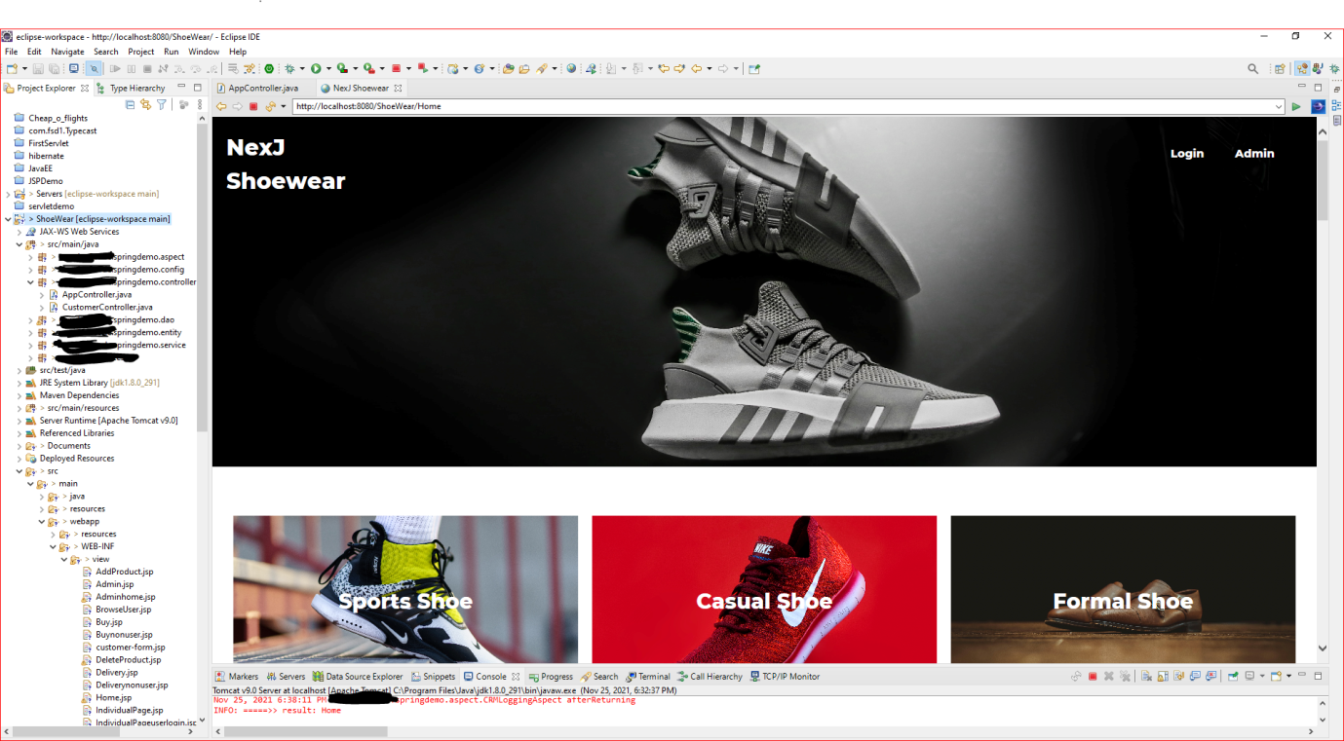

**User Home Page**

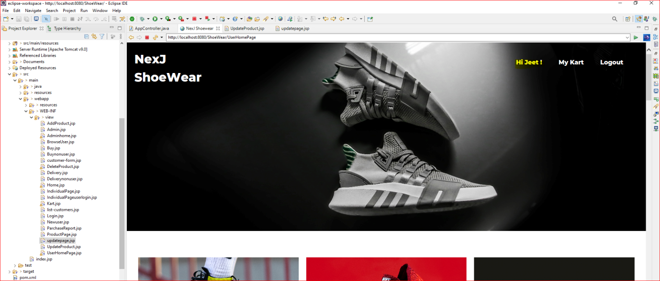

**Admin Home Page**

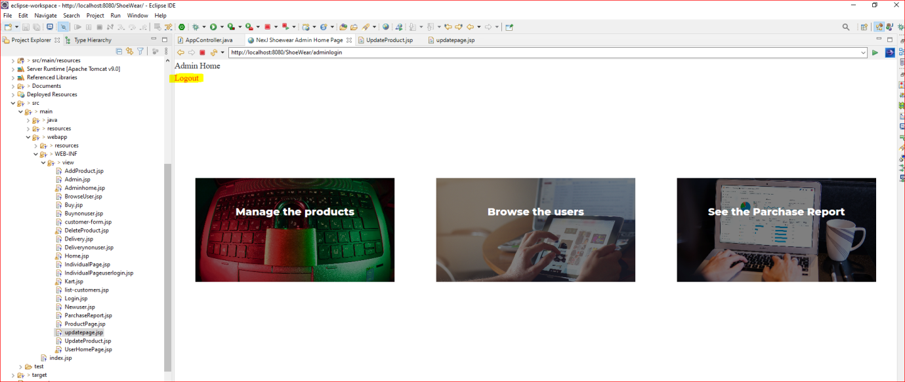

**User Logins:**

**Admin:**

**User id - Admin**

**Password - 123**

**User:**

**User id – Jeet**

**Password – Jeet**